INCLUDE CULTURE IN YOUR NATIONAL RECOVERY STRATEGIES AND REACTIVATE CULTURAL LIFE IN EUROPE
Dissemination toolkit
Joint social media action Friday, 19 March 2021, 11 am CET
Letter embargoed until Thursday, 18 March 2021 (when it is sent to the national governments and relevant Commissioners)

- Upload the open letter on your websites and/or include in your Newsletters. Possible announcement text:
[TITLE] Secure a future for cultural life in Europe

Following the open letter published by 110 pan-European networks on 30 October 2020 “Make culture central in the EU recovery”, the group comes together again to reiterate their call to the national governments and the European Commission. In the second open letter [LINK] published today by the group, coordinated by Culture Action Europe, the European cultural community call on the Member States and the European Commission to secure a future for culture and cultural life in Europe.

Culture must be included in each and every National Recovery and Resilience Plan (NRRP) that EU countries should present to the European Commission before the 30 April deadline. The representatives of the European cultural ecosystem urge governments to dedicate at least 2% of the Recovery Fund to culture and put culture as a priority sector when using funds from Next Generation EU. In addition, 110 cultural networks call on the Member States to engage with the representatives of their cultural communities and civil society organisations in the design and implementation of the NRRPs. “Long-term structural support to rebuild the European cultural ecosystem needs to be co-developed, involving all relevant stakeholders, both public and private”, - reads the letter.

Ensuring that culture is explicitly included in the NRRPs will help secure both the future of the sector and its important contribution to Europe’s future. Reinvigorating the cultural ecosystem not only offers hope to millions of workers who saw their jobs endangered by the pandemic, it can also create new meaning and purpose to all Europeans and the European project.

Read the letter in full [LINK]

- Press Release

The text above can be used as the basis of your press release.

Feel free to include this quote from Tere Badia, Secretary General of Culture Action Europe:

“It is crucial that culture is made central in national recovery plans, with a dedicated budget to reactivate the sector. Now is the time for implementing effective measures to avoid a post-pandemic desert in the cultural ecosystem and mainstream culture as a priority dimension in the EU policy thinking and funds-allocation.”

In addition, include a quote from the representative of your organisation.

Note to the editors:

Culture Action Europe (CAE) is the major European network of cultural networks, organisations, artists, activists, academics and policymakers. CAE is the first port of call for informed opinion and debate about arts and cultural policy in the EU. As the only intersectoral network, it brings together all practices in culture, from the performing arts to literature, the visual arts, design and cross-arts initiatives, to community centres and activist groups.

CAE believes in the value and values of culture and its contribution to the development of sustainable and inclusive societies. www.cultureactioneurope.org

[INCLUDE BIO OF YOUR ORGANISATION]

This joint letter is endorsed by 110 pan-European cultural networks, representing European cultural and creative sectors and industries.

For press inquiries, please contact:

Gabriele Rosana (Culture Action Europe) policy@cultureactioneurope.org
Natalie Giorgadze (Culture Action Europe) communication@cultureactioneurope.org
[ADDITIONAL CONTACTS FROM YOUR ORGANISATION]

- Publish the letter on Twitter on Friday, 19 March at 11am CET on Twitter

Suggested tweets:

#NoCultureNoFuture
Cultural life in Europe needs urgent support!

A group of 110 pan-European cultural networks urge Member States not to forget culture in their #NRRPs and dedicate at least 2% of their Recovery Funds to #culture

[LINK TO THE LETTER]

#NoCultureNoFuture

The European cultural community calls to secure a future for #culture & cultural life in #Europe. Hit hard by #Covid_19, the sector needs immediate support. Include & earmark 2% for #culture in #NRRPs

A call for action from 110 cultural networks

[LINK TO THE LETTER]

#NoCultureNoFuture

Give hope to millions of cultural workers lost their jobs during #Covid_19, reinvigorate #cultural #ecosystem, offer new meaning and purpose to all Europeans!

Cultural actors put pressure on EU Member States to include #culture in #NRRP

[LINK TO THE LETTER]

#NoCultureNoFuture

#Culture is a vector for the #sustainable future for all! It heals wounds, keeps societies together, makes them #resilient

#Culture must be put at the heart of Europe’s recovery. #Culture needs timely & adequate support.

110 networks' call

[LINK TO THE LETTER]
Possible twitter visuals:

These visuals have been developed by Culture Action Europe as part of the #CulturalDealEU campaign. As some of the calls of the Deal are reiterated in the open letter, CAE will be re-using these visuals on social media.

We are happy to put these images at your disposal, feel free to decide whether you want to use them or not.

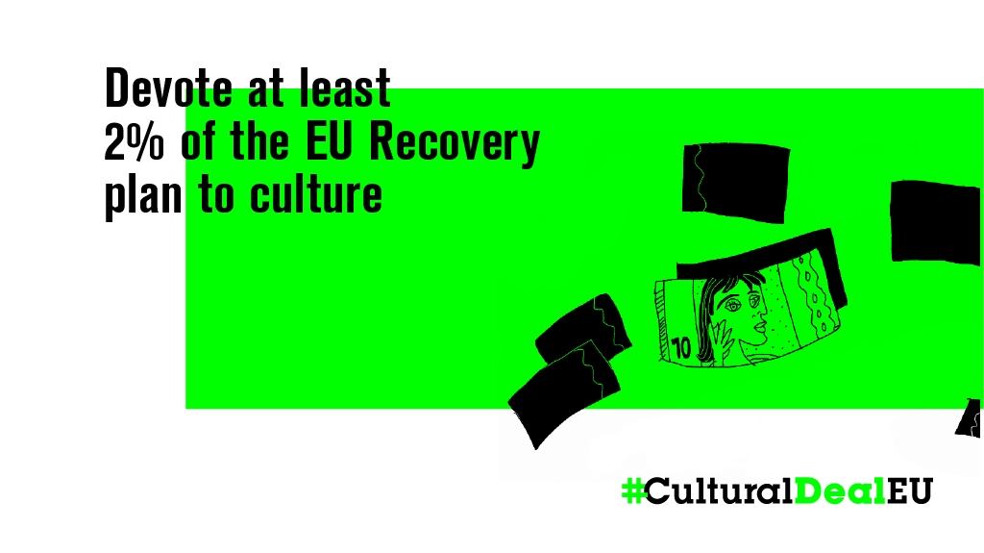

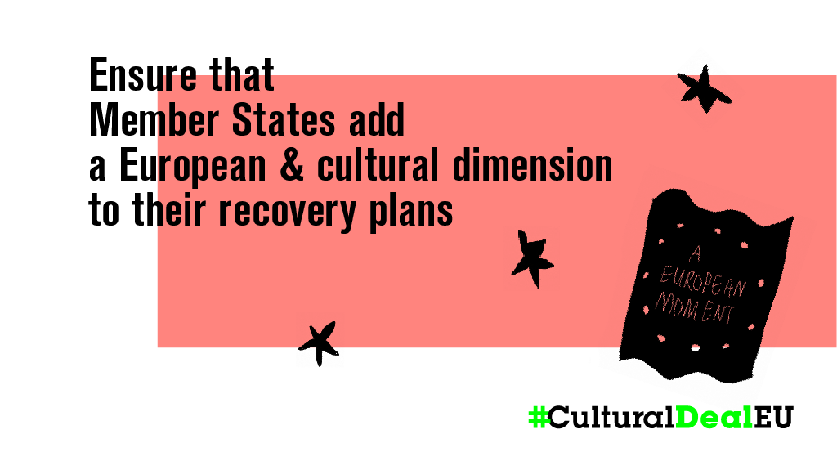

Suggested tags:

Ministers of Culture

@WKogler
@BenedicteLinard
@JanJambon
@KChampiaouris
@ZaoralekL
@BundesKultur
@Joymogensen
@jmrdezuribes
@KosonenHanna
@R_Bachelot
@NObuljen
@josephamadigan
@dariofrance
@SamTanson
@JoseHerreraMP
@ivanengelshoven
@gracafonseca
@ministrstvozakulturo
@amandalind_

EU Institutions:

@vonderleyen
@EP_President
@eucopresident
@RPPortugalUE
@TimmermansEU
@VDombrovskis
@vestager
@VeraJourova
@MargSchinas
@GabrielMariya
@ThierryBreton
@PaoloGentiloni
@sabineverheyen
@RomeoFranz1
@laurencefarreng
@AlexisMep
@nnienass
@HannesHeide
@DomenecD
@maxsmeriglio
@salima_yenbou
@CultCreatorsEU

